# ‘



**Final Project Report**

**On**

REMIND ME

(Android Based Application)

**Prepared By**

SHAFIQ AHMED (CIIT/FA15 -MCS-018/SWL)

AAMIR RASHID (CIIT/FA15 -MCS-022/SWL)

**Supervised By**

Dr. Javed Farzand

**Computer Sciences Department**

**CIIT, Sahiwal**

May 2017



**COMSATS Institute of Information Technology, Sahiwal**

|  |
| --- |
|  |

**DEDICATION**

Our Parents and Teachers all who’ve given us their support during the development of this project and for giving good ideas to prove ourselves as intellectuals in front of our Respected Teachers.

**Acknowledgement**

All thanks to Allah the Almighty who is our best friend and knows us more than ourselves. He is always with us in our difficulties and problems.

At the completion of this project, we want to express our deepest gratitude to our supervisor “Dr Javed Farzand”. He was always there to help us and encourage us when obstacles came in our way. He share his experience with us so that we can get more logical understanding on how to develop a application which is suitable for the society. He is a constant source of knowledge, guidance and provided valuable comments, positive criticism and encouragement throughout our work. Without his support it would have been difficult to complete the work.

We sincerely thank our parent’s, family and friends for all support, encouragement and patience they have provided us with throughout our academia. It is our greatest pleasure to acknowledge the efforts, guidance of our Head of Department.

We would also like to acknowledge the efforts and knowledge of COMSATS staff, professors and Instructor who provide us with the help, support and guidance throughout academic period.

Accept the authors regards.

**Declaration**

We hereby declare that this application, neither whole nor as a part, has been copied out from any source. It is further declared that we have developed this application and accompanied report entirely on the basis of our personal efforts. If any part of this project is proved to be copied out from any source or found to be reproduction of some other. We will stand by the consequences. No portion of the work presented has been submitted of any application for any other degree or qualification of this or any other university or institute of learning.

Students Name & Signature

______________ ________________

**Shafiq Ahmed** **Aamir Rashid**

**Certificate of Approval**

Certificated that work contained in this project

**“Remind Me(Android Based Application)”**

It is to certify that the final year project of MCS “Remind Me” was developed by Shafiq Ahmad and Aamir Rashid under the supervision of “Dr. Javed Farzand” and that in his opinion it is fully adequate, in scope and quality for the degree of MCS.

Supervisor: Dr.Javed Farzund

**Supervisor External Examiner**

**Head of Department**

[Dr. Javed Ferzund](http://ww3.comsats.edu.pk/faculty/FacultyDetails.aspx?Uid=20727)

Department of Computer Science

CIIT Sahiwal

**Abstract**

This report documents the Final Year Project entitled as “**Remind Me**”. To achieve this task Android App which is developed to set or schedule meetings and personal reminders on the android devices. The “**Remind Me**” is able to set reminder manually by hand and through voice by using Google API.AI. This App is developed to facilitate users to set alarm , reminders and meetings without any hand interaction with device but with voice to set all schedules.

The report’s chapter included introduction, requirement analysis, planning and designing, implementation, testing. The introduction phase gives an overview of the project describing its background, scope and main objectives. Requirement analysis is the phase to gather user requirements such as functional and non-functional requirements. Next is the system design is mainly used to design the user interface and database design. The next stage after designing is the implementation phase. After this part testing is carried out to locate any possible bugs.

Table of Contents

Contents

Presented by: 0

Dedication: 1

Acknowledgement 2

Declaration 3

Certificate of approval 4

Abstract 5

Chapter 1 9

INTRODUCTION 9

1.1 Introduction 10

1.2 Background 10

1.3 Problem Statement 10

1.4 Objectives 11

1.5 Motivation 11

1.6 General description of the project 11

1.7 Advantages of Remind me 11

Chapter 2 12

ANALYSIS PHASE 12

2.1 Requirement Gathering technique 13

2.2 Requirement Gathering technique 13

2.3 Requirement Analysis 13

2.3 Functional Requirements 13

2.3.1 Functional requirement 13

2.3.2 Non Functional requirement 14

2.4 Use Case 14

Table 1: user information 17

Table 2: System information 18

2.5 Softwae specification 18

2.6 External Interface requirements 18

2.6.1 User Interface 18

2.7 Software system atributes 18

2.7.1 Availability 19

2.7.2 Security 19

2.7.3 Maintaniability 19

2.7.4 Portability 20

CHAPTER 3 21

Planning and Design 22

3.1 Introduction 22

3.2 Planning and Scheduling 22

Table 1: Gantt chart 23

3.3 Sequence Diagram 24

3.4 System architectural design 25

3.5 Chosen System Architecture 25

3.6 Android Architecture 25

3.7 Software Process Model 29

3.8 Rules and Responsibilities 29

CHAPTER 4 30

Implimentation 31

4.1 Implementation Tools 31

4.1.1 Software Needed: 31

4.1.2 Network Interface: 31

4.2 Screen Shots 32

4.2.1 Splash Screen 32

4.2.2 Reminder List/Add Reminder 33

4.3 SQLite Database 40

4.4 Dependencies and constraints 40

Table 1: Database 41

CHAPTER 5 42

SYSTEM TESTING 42

5.1 System Testing 43

5.2 Introduction 43

5.3 Testing Plan 43

5.4 Unit Testing 43

5.5 System Testing 44

5.6 Integration Testing 44

5.7 User Acceptance Testing 44

CHAPTER 6 45

CONCLUSION AND FUTURE WORK 45

6.1. Conclusion 46

5.6 Future Work 46

6.3 References 47

**Chapter 1**

PROJECT INTRODUCTION

# 1.1 Introduction:

The “Remind Me” is the android application. We have to face many difficulties in the manual system. Auto remainder gives the facility to schedule a meeting with many people on desire time and date. It also helps the user to put information through voice and then perform an action on the user request. Today life is a busy life and every user wants automation via devices on this app will allow device to be more frank with user to perform his action automatically with user voice and perform an action on user voice and recognize it through API.AI.

.

**1.2 Background:**

Remind me is the android based application. This app enhances user interaction and get rid of many manual work. This application help user to put Information once in it and will inform automatically on the regarding date and time, via text and alarm based information. It also provides facility to put info through voice and perform the action on the user request. “Remind Me” will be intelligent to recognize user voice by using Google API.AI and then get information from user.

**1.3 Problem statement:**

Being a part of technological world, People like to use the technology fully and in their busy lives they forget some important things this will tell you about your important works to b done it on time. These days many automation devices are invented. This App is also schedule a meeting and then send and inform other participants via text and with alarm.

This app will allow device to be more frank with user to perform his action automatically.

**1.4 Objectives**

The main objectives of our project are followings

* Facility of automatically remind the things
* Fix the meeting with many persons on desired date and time.
* Put information through voice and then perform the action on the

user request

**1.5 Motivation**

The “Remind Me” is basically an automation app which is using Google API.AI to recognize user voice and actions and then perform the desired task of users choice and give user frankness with it and it is also a time saving app which will do all the things with voice without any hand interactions and then automatically informed user about reminder and schedule meeting and inform others via text to participants and via alarm on user phone.

**1.6 General description of the project**

The “Remind Me” is the time saver. Users do not waste their time in term of to remember the most things. It is the easy mechanism to remind the things properly instead of forgetting some important things. It will be intelligent to recognize user voice by using API.AI and then get information from user then set schedule for him/her automatically.

**1.7 Advantages of Remind Me**

This project aims to make an android app to provide the user facility in the busy life the user. User can manage their work by using this app the meetings will be held on time and the schedule of meeting will be held by automatically through voice and via texting.

* Time saving
* Get rid of more manual work
* All the work can also be done with voice
* Time Management

**Chapter 2**

ANALYSIS PHASE

**2.1 Introduction**

In this chapter we will focus on the feasibility of the project. Requirement collection is the chief desirability of the phase of Analysis. The process of collecting requirements is usually more difficult than simply asking the questions from users that what they need and writing their answers down. Depending on the complexity of the application, the process for collecting requirements has a visibly defined process of its own. We will also focus on which technique we use to develop this project.

## 2.2Requirement Gathering technique

A **requirement** can be defined as capability or condition that must be possessed by the system, service, result, and product. Different techniques can be used for collecting requirements.

* Focus on facilitated workshops and groups
* Using creativity groups and using techniques of decision-making
* Surveys and Questionnaire
* By Observation
* Use of Prototyping
* Using Software tools

## 2.3Requirement Analysis

Requirement analysis is a process of studying and analyzing the customer needs to arrive at the definition of software requirement. It is divided into two parts.

1. Functional requirements
2. Non functional requirements

### 2.3.1Functional requirement

Functional requirements can be defined as the services statements that should be provided by the system that how the system will react to the particular input and how in different situations the system should behave.

The functional requirements of system are following:

**REQ-F1:** Set the meeting automatically

**REQ-F2:** Set the schedule through voice commands

**REQ-F3:** Recognize voice through Google API.AI.

**REQ-F4:** Enhance user interaction

**2.3.2 Non Functional requirement**

Non-Functional requirements can be defined as the constraints or checks on the function or services provide by the system such as constraint of time, constraints on the development process and standards.

* **Performance**

System should provide better performance

* **Security and safety**

System shall provide Security and safety

* **Good quality**

System shall provide good quality

* **Efficient**

System should be efficient

* **Reliability**

System should be reliable

## 2.4 Use Case

In software & systems engineering, a use case is a list of steps typically defining interactions between a role (known in unified Modeling Language (UML) as an “actor”) and a system, to achieve a goal. The actor can be a human, an external system or time.

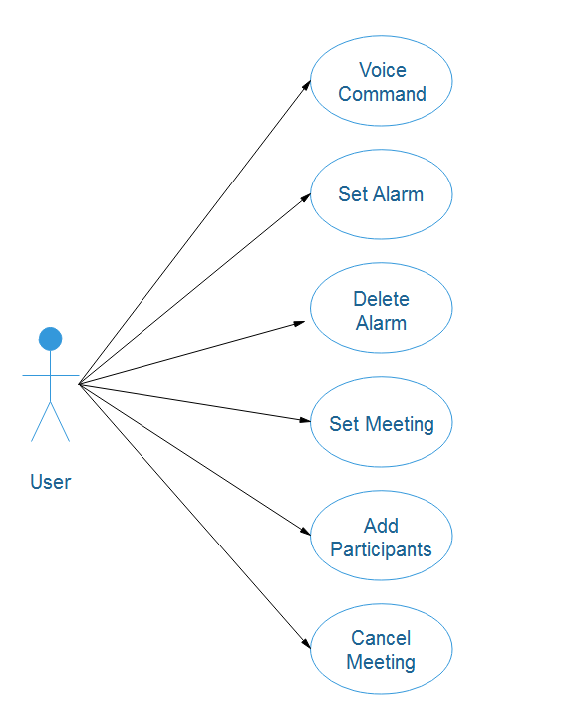

Figure 1: Use case Model for User

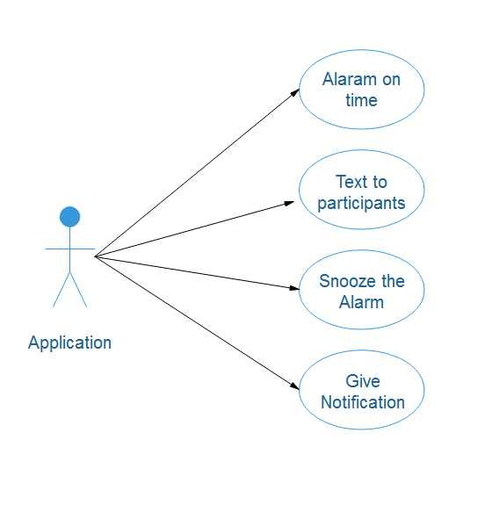

Figure 2: Use case model for System/Application

**Table 1: User information**

|  |  |
| --- | --- |
| **Use Case Name:** | User view in systematic way |
| **Use Case ID:** | UC 101 |
| **Actors:** | User and System |
| **Summary Description:** | The Users gives instructions to system to perform actions |
| **Priority:** | Must Have |
| **Risk Level:** | High |
| **Status:** | Fully Detailed |
| **Pre-Condition:** | User must have familiar to their system and have a internet connection. |
| **Post-Condition:** | No User can perform all operations that are irrelevant. |
| **Alternative Paths:** | None |
| **Non-Functional Requirements:** | Reliability |

### 

### Table 2: System information

|  |  |
| --- | --- |
| **Use Case Name:** | System |
| **Use Case ID:** | UC 102 |
| **Actors:** | Application/System |
| **Summary Description:** | Application is able to set alarm on user time and date |
| **Priority:** | Must Have |
| **Risk Level:** | High |
| **Status:** | Fully Detailed |
| **Pre-Condition:** | Application must require internet connection for API.AI |
| **Post-Condition:** | Application can set alarm , reminder , and schedule meetings. |

**2.5 Software specification:**

In software requirement specification we are targeting the men and women both because of their busy schedule in their busy life to perform the actions on their devices automatically without even pressing the buttons.

**2.6 External interface requirement:**

**2.6.1 User interface**

System will provide the facility for the users to access the ‘’Remind Me’’ via internet. The users provide a very natural interaction between the user and android devices. This app provides the feature to the users that allow the user platform those actions on their devices automatically without even pressing the buttons. It contain the automatic time schedule send the message through voice commands, set the meetings on the daily basis, all work are done by using the Google API.AI.

**2.7 Software system attributes:**

Following are the software system attributes are as follows:

1. **High Availability:**

High Availability is the measure of the quality of software to keep functioning in spite of problems. Since the ‘problems’ can be of many types, different technologies work in tandem to achieve high availability for the overall system. High Availability is achieved through many means.

1. **a- Architectural Means**
2. **Dispatcher / Server** Model As described in the Technology white paper, all Switching and AAA products work on a Dispatcher / Server model where the Dispatcher distributes work on the Serving nodes. In addition to load balancing, it has high availability benefits as well because when a Serving node goes down, the Dispatcher fails over the load to the remaining Serving nodes without the Clients even knowing the change.
3. **Real-Time Replication:**

All the actions and there responses are on online database of Google api.ai that app will use to ask and communicate with user to set meetings, reminders etc.

**b- Technological Means**

1. **Data security:**

It provides the facility of data security.

* + 1. **Availability:**

The app available when the mobile phone is connected to the Internet.

**2.7.2 Security:**

There are safety requirements with this application, other than any normal security of a mobile device. The security is most important in this app while you are not using your cell phone, when in a meeting, when in office or when in a new place security is the core element in this application. The information must be kept secure. All user input shall be cleaned to prevent security issues. This will ensure any malicious entries will not harm the cell phone.

* + 1. **Maintainability:**

Any update or defects shall be able on the server or admin side.

* + 1. **Portability:**

There is no portability require

CHAPTER 3

**PLANNING AND DESIGN**

**3.1 Introduction**

Remind Me is the android application. We have to face many difficulties in the manual system. Auto remainder gives the facility to schedule a meeting with many people on desire time and date. It also helps the user to put information through voice and then perform an action on the user request. Today life is a busy life and every user wants automation via devices on this app will allow device to be more frank with user to perform his action automatically.

**3.2 Planning and Scheduling**

A Gantt chart is used for planning and scheduling. It is used for the representation of the activities in contrast of time. On the vertical side of the chart activities list is displayed and on the top a time scale, which is appropriate. A bar represents each activity the length and position of the bar that shows the start date, end date and duration of the activity.

These show the following activities are as follows:

* What the different activities are?”
* When an activity starts and ends?”
* How much long each activity is scheduled to finish?”

The Gantt chart of our project is shown below:

**Table 4: Gantt chart**

|  |  |  |  |  |  |  |  |  |  |  |  |  |  |  |
| --- | --- | --- | --- | --- | --- | --- | --- | --- | --- | --- | --- | --- | --- | --- |
| No | Activity | September 2016 | | | | October 2016 | | Nov-Dec2016 | Jan 2017 | Feb.  17 | March  17 | March 16 | April 17 | |
| 2 | 12 | 15 | 25 | 05 | 25 | 10 |  |  |  | 07 | 07 | 15 |
| 1 | Project Idea |  |  |  |  |  |  |  |  |  |  |  |  |  |
| 2 | Kick off meeting |  |  |  |  |  |  |  |  |  |  |  |  |  |
| 3 | Pre-feasibility study of the project |  |  |  |  |  |  |  |  |  |  |  |  |  |
| 4 | Administrative application approval of the project |  |  |  |  |  |  |  |  |  |  |  |  |  |
| 5 | Preparation of DPR |  |  |  |  |  |  |  |  |  |  |  |  |  |
| 6 | Sanctioning of DPR |  |  |  |  |  |  |  |  |  |  |  |  |  |
| 7 | Implementation of the project |  |  |  |  |  |  |  |  |  |  |  |  |  |
| 8 | Overview of the progress |  |  |  |  |  |  |  |  |  |  |  |  |  |
| 9 | Sending the completion report of the project |  |  |  |  |  |  |  |  |  |  |  |  |  |

**3.3 Sequence Diagram**

Graphical representations of stepwise workflow of action sequence of information between application and user and application and Google server is shown in the sequence diagram with support for iteration concurrency and choice. In the UML (Unified Modeling Language), sequence diagram represents the flow of information.

**Figure 3: Users Sequence diagram**

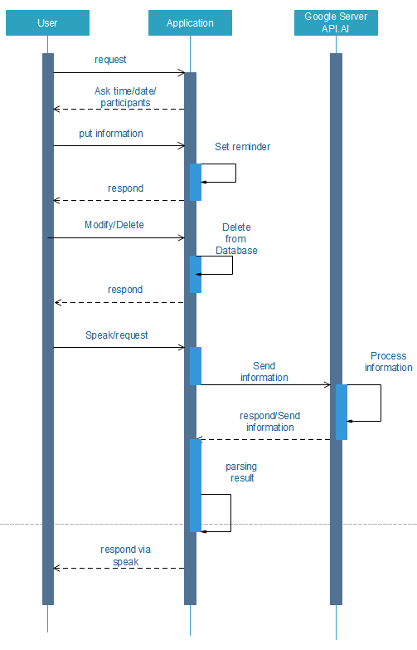

**3.4 SYSTEM ARCHITECTURAL DESIGN**

In system architecture design there are two types of actors are used .

* User/Application
* Application/Google Server API.AI.

In this system the database will be used to keep the record of all reminders and meetings that will be scheduled by user. The data from the database will be fetch and show on different desired screens such as reminder list, add reminder so that user will see all the information even if the application will restart. The database will create at the installation of the application in the mobile device.

## 

**3.5 Chosen System Architecture**

“Remind Me” use client server architecture that will enable the each mobile phone to connect with internet connection and allows conversation between user and application and enhance the user experience and give him more frankness.

**3.6 Android Architecture**

Android is an open source, Linux-based software stack created for a wide array of devices and form factors. The following diagram shows the major components of the Android platform.

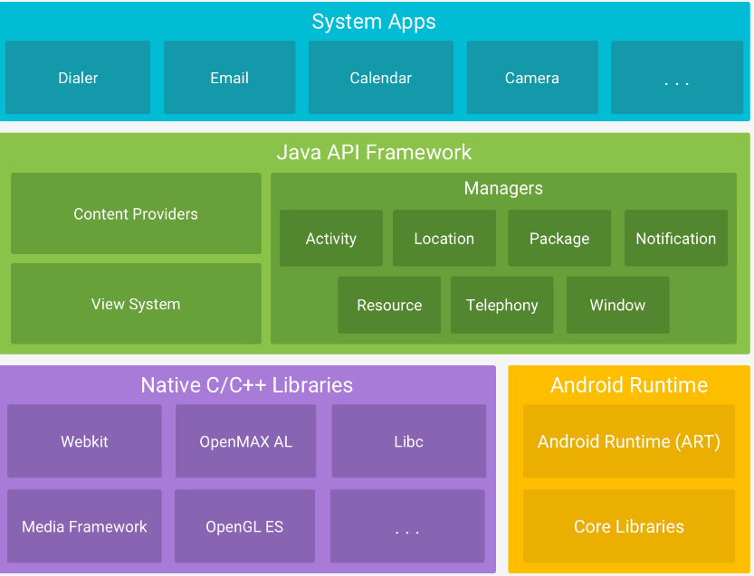

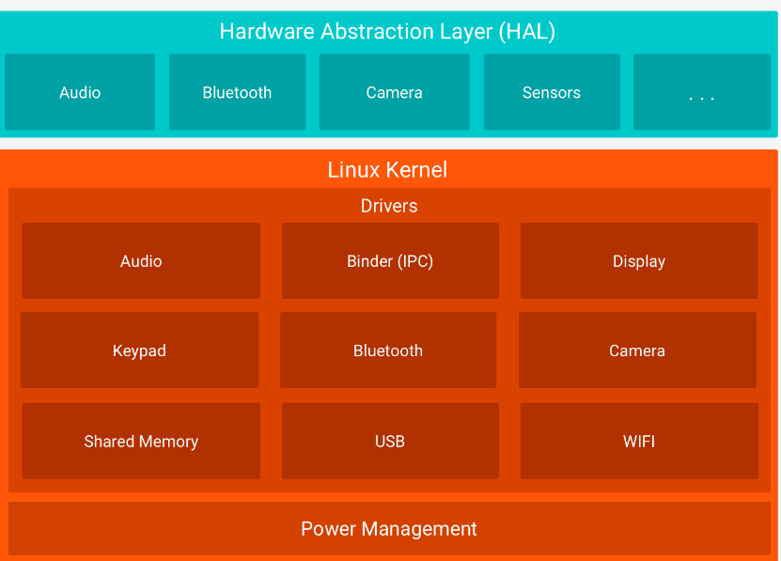

**The Activity Life Cycle concept**

To navigate transitions between stages of the activity lifecycle, the Activity class provides a core set of six callbacks: [onCreate()](https://developer.android.com/reference/android/app/Activity.html#onCreate(android.os.Bundle)), [onStart()](https://developer.android.com/reference/android/app/Activity.html#onStart()),[onResume()](https://developer.android.com/reference/android/app/Activity.html#onResume()), [onPause()](https://developer.android.com/reference/android/app/Activity.html#onPause()), [onStop()](https://developer.android.com/reference/android/app/Activity.html#onStop()), and [onDestroy()](https://developer.android.com/reference/android/app/Activity.html#onDestroy()). The system invokes each of these callbacks as an activity enters a new state.

Figure 1 presents a visual representation of this paradigm.

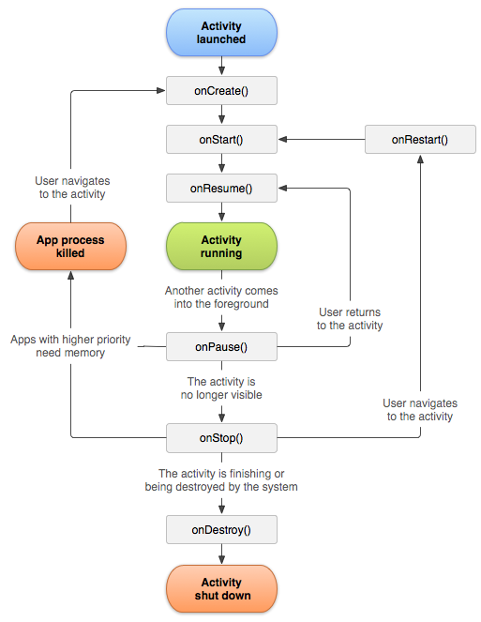

**3.7 Software Process Model**

We use Extreme Programming from agile methodologies in this project.

**3.8 Roles and Responsibilities**

In order to collectively accomplish the goal of this project the members are working on some work (coding, research) in parallel so the best one will lead us towards its completeness and some responsibilities are assigned individually like report.

|  |  |
| --- | --- |
|  |  |

# 

CHAPTER 4

**IMPLEMANTATION**

# 

**4. Introduction**

The most important goal of this phase is to develop the application. The work in this phase should be much more straightforward as a result of the work done in the planning and design phases. This phase involves changing design specifications into executable programs.  When the design is there, developers can have an idea on looks of application. All that is needed by developers is to put them at one place to understand about the intended project.

**4.1 Implementation Tools**

**4.1.1 Software Needed:**

Operating system (Microsoft Windows 8 Recommended)

Android Studio

java, SQLite database.

**4.1.2 Network Interface:**

The user must have Internet connectivity in order to access API.AI for voice commands for automatically set reminder and meetings. Application has permissions to access the network to connect the internet.

**4.2 Screen Shots**

**4.2.1 Splash Screen**

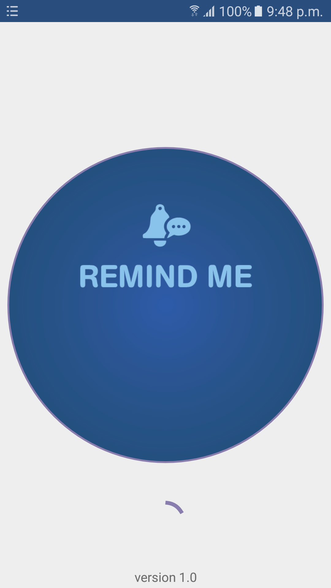

**4.2.2 Reminder List**

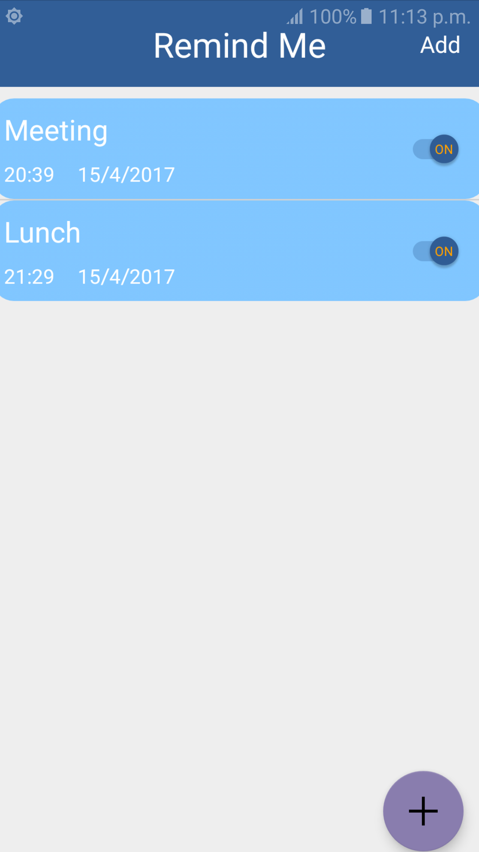

**4.2.2 Add Reminder Activity and interfaces for time and date picker and contacts**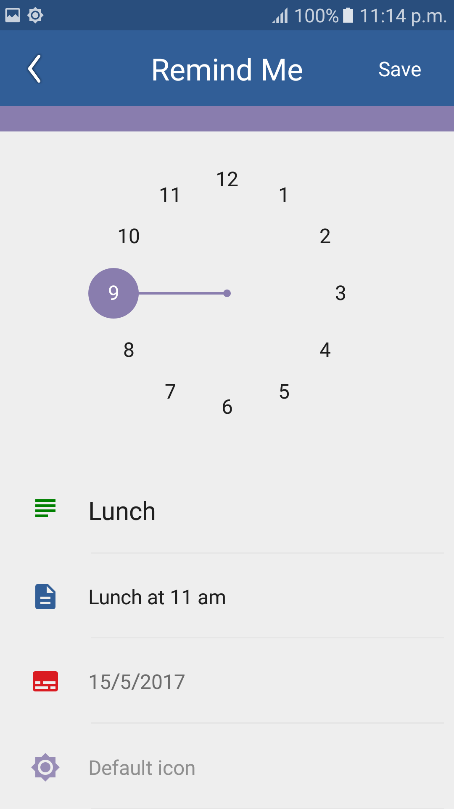

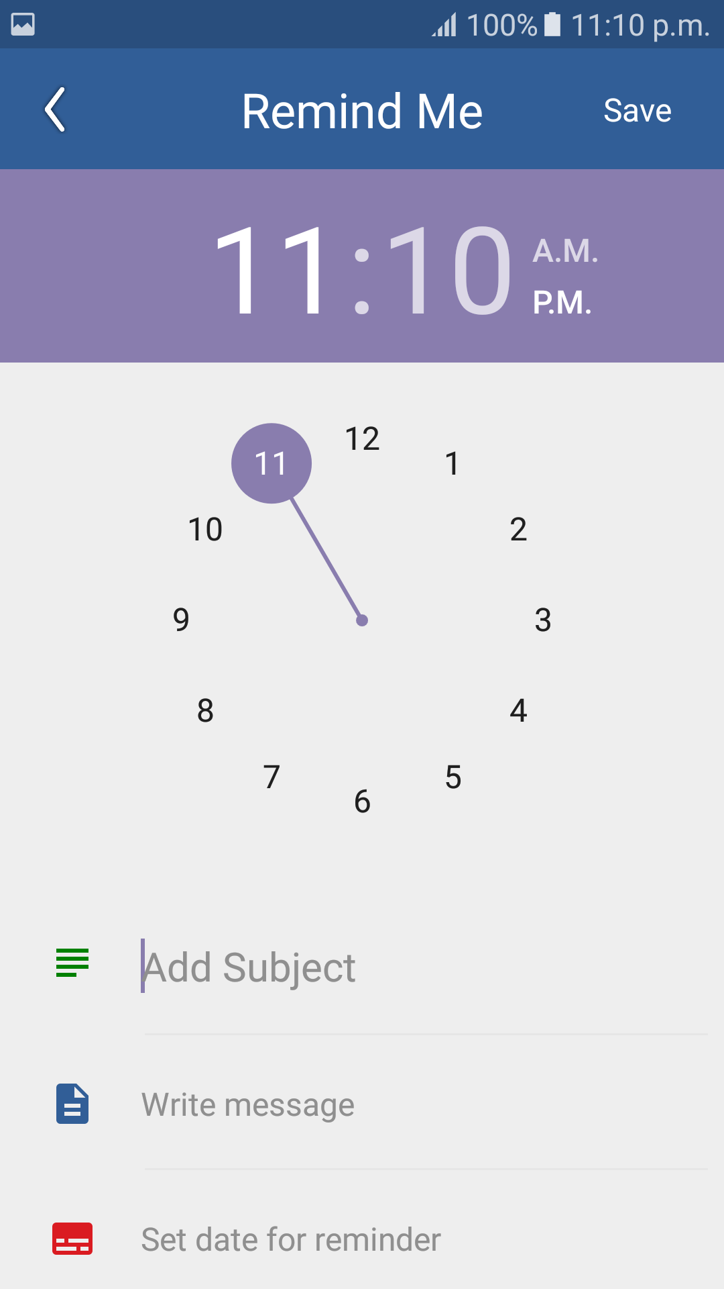

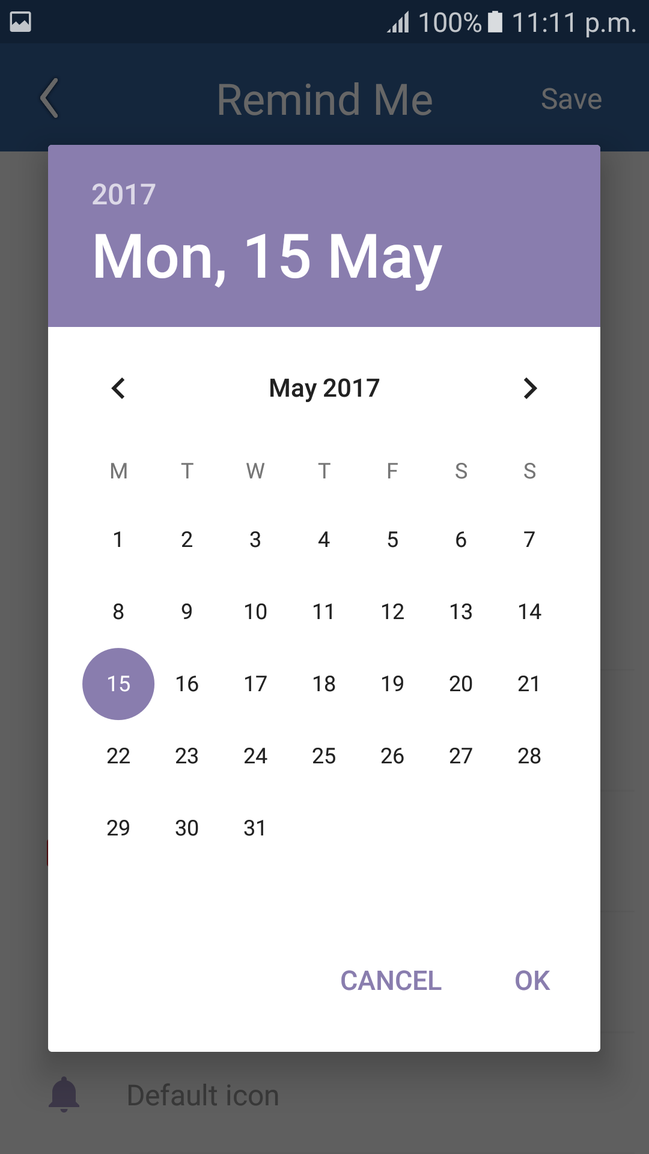

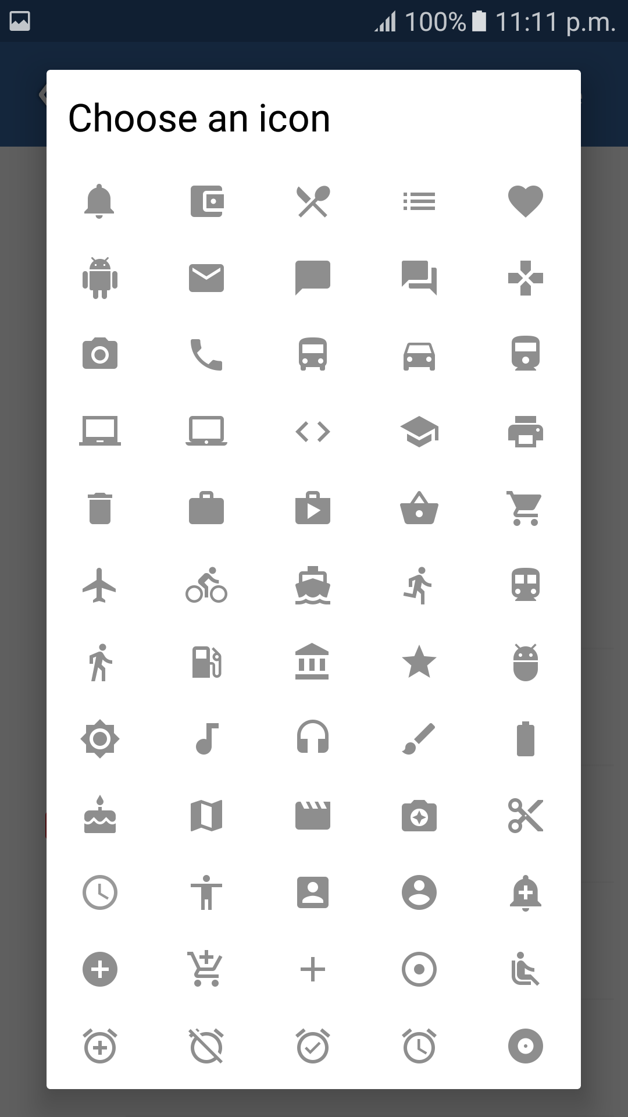

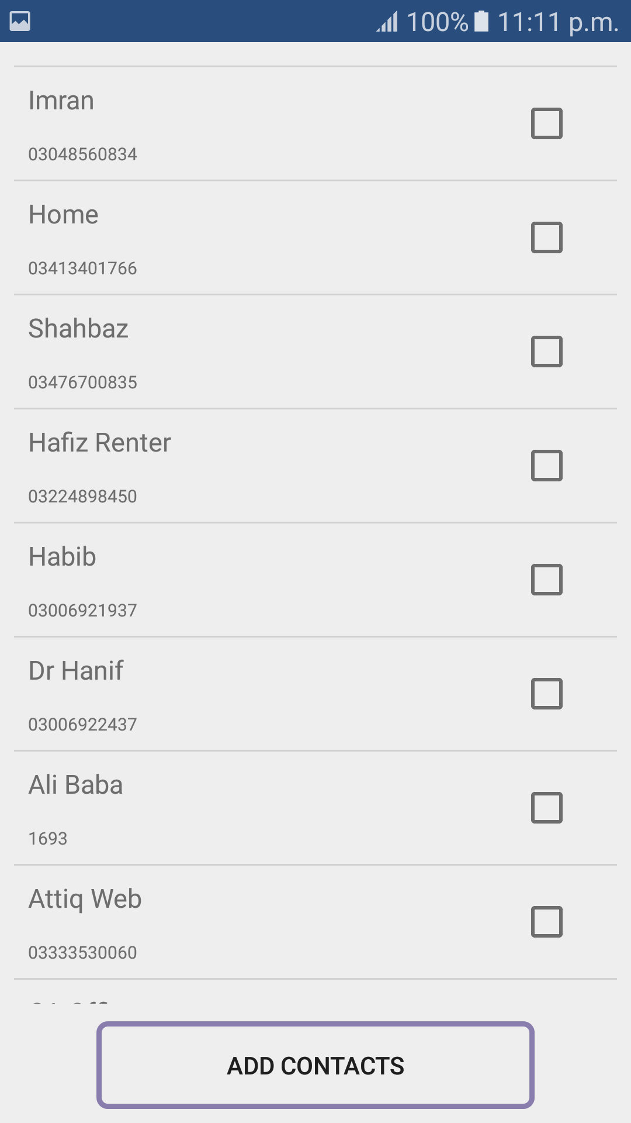

**4.3 SQLite Database**

Saving data to a database is ideal for repeating or structured data, such as contact information. This class assumes that we are familiar with SQL databases in general and helps you get started with SQLite databases on Android. The APIs you'll need to use a database on Android are available in the  [android.database.sqlite](https://developer.android.com/reference/android/database/sqlite/package-summary.html)  package content indexing and delivery software, highly available redundant systems, online transaction processing (OLTP), and much more.

**4.4 Dependencies and Constraints**

The constraints are as follows

* Internet is necessary for voice commands.
* Application must have GSM connection to send SMS.
* Application will only install in android devices.

**Table 1: Database**

Data dictionaries:

Reminder_table:

|  |  |
| --- | --- |
| **Parameter Name** | **Parameter type** |
| Reminder Id | Integer |
| Reminder Subject | String |
| Reminder Time | String |
| Reminder Date | String |
| Participants | String |
| Icon | Integer |
| Message | String |

CHAPTER 5

**SYSTEM TESTING**

# 5.1 SYSTEM TESTING

In this chapter, we will discuss the testing phase of developed application “Remind Me”

in different manner to know that how much efficient and effective application is?

# 5.2 Introduction

A process of performing as application or program with the intention of finding errors and whether the application is fulfilling user needs. It can also be defined as the ability of a program in meeting the required or desired results.

In many methodologies of software engineering, a separate phase is called phase of testing which is performed after the completion of the implementation. There is a benefit in using this approach that it is hard to see one's own mistakes, and a fresh eye can find observable errors much faster than the person who has read the material many times.

# 5.3 Testing Plan

A process of performing as application or program with the intention of finding errors and whether the application is fulfilling user needs.

# 5.4 Unit Testing

The software units in an application are modules and routines that are assembled and integrated to perform a specific function. Unit testing focuses first on modules, independently of one another, to locate errors. This enables, to detect errors in coding and logic that are contained within each module. This testing includes entering data and ascertaining if the value matches to the type and size supported by C#. The various controls are tested to ensure that each performs its action as required.

Commonly used method is White-Box Testing method. Every time a component of the program is changed, it can be run for testing that is the biggest and famous benefit of this testing phase. Issues that are arises during this phase, allowing to be resolved as quickly as possible. Unit testing is familiar by software developers. It allows them to test their application units before move them to testers for formal testing.

# 5.5 System Testing

To test the complete application as a whole, system testing has been used. It is beneficial to check whether the application meets its requirements and fulfill Quality Standards.

# 5.6 Integration Testing

Integration testing allows the software developers to integrate all of the components/ units of the application within a program and then test them in a group. Basically, this testing level is used to catch the defects in the user interface between the functions/ modules. It is useful to determines how logically and efficiently all the units/ components are running together.

Here the streaming module and encoding module options are integrated and tested. This testing provides the assurance that the application is well integrated functional unit with smooth transition of data.

# 5.7 User Acceptance Testing

User acceptance of an application is the key factor for the success of any application. The application under consideration is tested for user acceptance by constantly keeping in touch with the application users at time of developing and making changes whenever required.

CHAPTER 6

## CONCLUSION AND FUTURE WORK

# 

# 6.1 Conclusion

Hence we concluded that Remind Me is easy and better as compare to manual system.

## 6.2 Future Work

We focus on the following future direction are as follows:

* The main focus on more android functionality.
* We will expand our app to global level by sponsoring it.
* To make the user interface more user friendly.

# 6.3 References

1. Android Google Developer www.developer.google.com
2. [www.stackoverflow.com](http://www.stackoverflow.com)
3. [www.youtube.com](http://www.youtube.com)
4. Professional ANDROID 4 Application Development by Reto Meier
5. BEGINNING ANDROID APPLICATION DEVELOPMENT by Wei-Meng Lee
6. https://www.android.com
7. <https://developer.android.com/guide/components/activities.html>
8. <https://developer.android.com/guide/topics/ui/declaring-layout.html>
9. <https://developers.google.com/maps/documentation/javascript/markers>
10. <https://www.youtube.com/user/androiddevelopers>